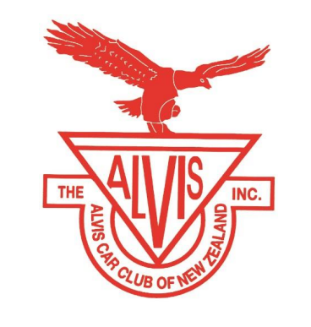
THE ALVIS CAR CLUB OF NEW ZEALAND INC.

ABOUT ALVIS IN NEW ZEALAND

Alvis cars were produced in Coventry, England from 1920 to 1967. Of the 21535 cars built, over 200 came to New Zealand of which over 80 are in regular use. The Alvis Car Club of New Zealand was formed in 1969 and currently has over 100 members.

AIMS
- To foster and preserve the name and reputation of the Alvis cars.
- To assist members to restore, maintain and drive Alvis cars.
- To bring together those with an enthusiasm for Alvis cars.

BENEFITS
- An informational bi-monthly newsletter is emailed to you.
- Access to a comprehensive spare parts and technical service.
- An annual AGM weekend rally, alternating yearly between the North and South Island.
- Social events, tours, rallies, workshop technical visits, dinners, sightseeing, shows and displays.

MEMBERSHIP
- To qualify as a full member of the Alvis Car Club of New Zealand, ownership or part ownership is required.
- A prospective member not owning an Alvis but with interest in the marque would qualify as an associate member.
- The annual subscription is ☐$40 including emailed newsletter.

APPLICATION FORM

NAME (OWNER)- Click or tap here to enter text.
SPOUSE/PARTNER- Click or tap here to enter text.
ADDRESS- Click or tap here to enter text.
PHONE- Click or tap here to enter text. EMAIL- Click or tap here to enter text.
ALVIS MODEL- Click or tap here to enter text.YEAR- Click or tap here to enter text.
REGO. NO- Click or tap here to enter text. CHASSIS NO.-Click or tap here to enter text.
ENGINE NO.-Click tap here to enter text. ☐RUNNING ☐BEING RESTORED

PAYMENT: Internet banking 02-0184-0172105-00, please use your name in reference box.

I DO☐/ DO NOT ☐ wish my name, address, or car details to appear on the Membership list circulated to members.
Please email your completed form to the Club President: Stuart Lind valdastuart@xtra.co.nz

